Lab 11: Deuterostomes

In this lab, we will be using pictures included at the end of this week’s PowerPoint as well as some videos. Please complete this worksheet and turn in via Blackboard. Make sure to read Chapter 14: Deuterostomes in the lab manual (pgs. 99-107).
- There will be several drawings/sketches required in this lab. Please make sure to preview your document before submitting on Blackboard to ensure it is still legible. (Hint: You can export your Microsoft Word file as a PDF or save your completed document as a PDF and submit the assignment as a PDF and this should eliminate any overlapping of pictures.)

Investigation 1: Echinoderm Embryology and Diversity
- Examine these pictures of sea star development. Circle the blastula stage and the middle gastrula stage. What is the difference between the two?

- Examine the pictures of different echinoderms below. What kind of symmetry do they have? Draw the axes of symmetry on one of the pictures to help you answer this question.

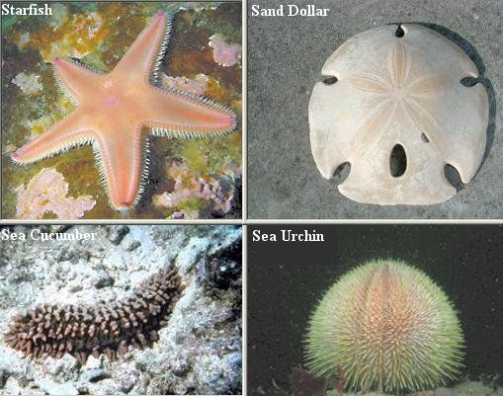
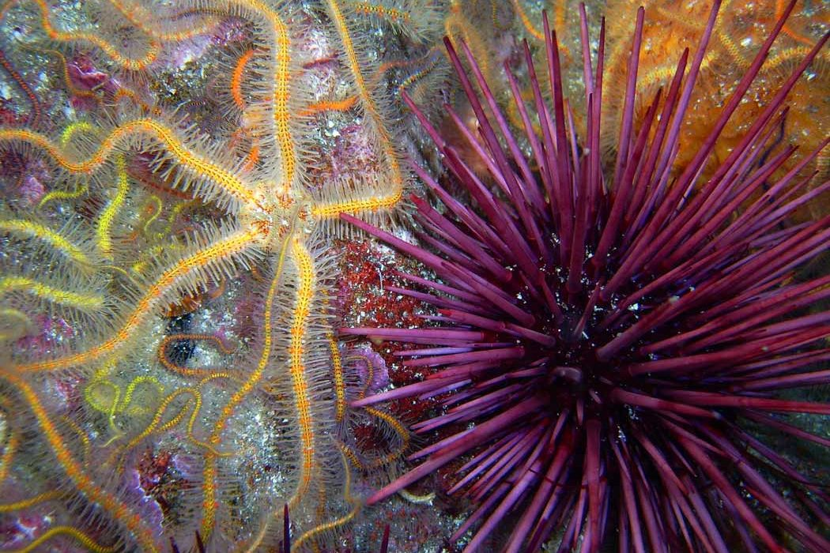

Investigation 2: Invertebrate Chordates
- Examine these images of Amphioxus and compare them to Figure 14.2 in your lab manuals. Do you see segmentation? Where? What are the four chordate characteristics present in Amphioxus?

- Observe this image of a lancelet cross-section. Locate and label the nerve cord and notochord. You can use Figure 14.2 for help.

Investigation 3: Perch Dissection
- a. Use the following links to study Perch anatomy and Perch dissection.
https://www.youtube.com/watch?v=yCfsrs6Y8M4
https://www.youtube.com/watch?v=r2u5roIr6x0
Draw a diagram of the exterior of the fish, labeling the fins, operculum, and lateral line.

b. Next, draw the interior of the fish, including the gills and digestive system. Use Figure 14.3 to help you with this.

Investigation 4: Survey of Terrestrial Vertebrates
- Examine these vertebrate forelimbs. Count the number of bones in each segment. Do they all follow the same pattern? Do some of the bones look fused in any of the limbs? Explain which ones in which animals?

- Observe these images of skins from different vertebrates. Are there any similarities between the avian feathers and reptile scales? Explain. Observe the feathers, scales, and fur. How does the structure relate to the function?

